National University of Computer and Emerging Sciences



AL-2002: Artificial Intelligence
Lab Manual 07

Department of Computer Science
FAST-NU, Lahore, Pakistan

Table of Contents
Objectives 3
1 Genetic Algorithm 3
1.1 Genetic Algorithm Flow 3
1.2 Population 4
1.3 Fitness and Selection 4
1.4 Mating / Crossover / Generating Generations 5
1.5 Mutation 5
2 Problem Solving using Genetic Algorithm 6

Objectives
After performing this lab, students shall be able to understand implementation of the following :
- Genetic Algorithm

Genetic Algorithm

A genetic algorithm (or GA) is a search technique used in computing to find true or approximate solutions to optimization and search problems. (GA)s are categorized as global search heuristics.
(GA)s are a particular class of evolutionary algorithms that use techniques inspired by evolutionary biology such as inheritance, mutation, selection, and crossover (also called recombination).

- The evolution usually starts from a population of randomly generated individuals and happens in generations.
- In each generation, the fitness of every individual in the population is evaluated, multiple individuals are selected from the current population (based on their fitness), and modified to form a new population.
- The new population is used in the next iteration of the algorithm.
- The algorithm terminates when either a maximum number of generations has been produced, or a satisfactory fitness level has been reached for the population.

1.1 Genetic Algorithm Flow

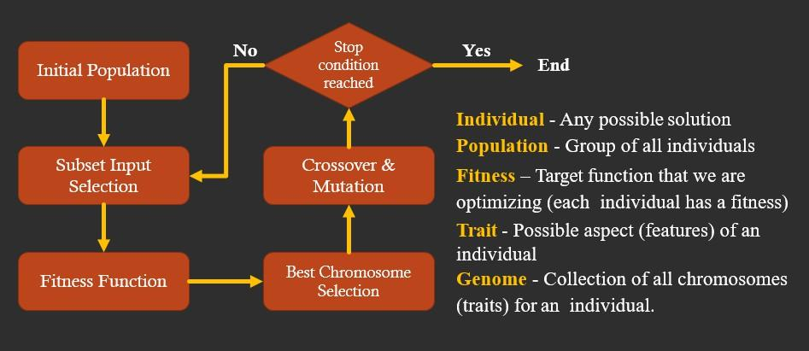

1.2 Population

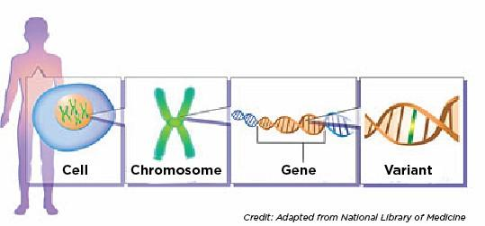
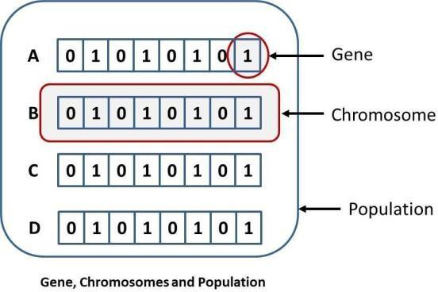

1.3 Fitness and Selection
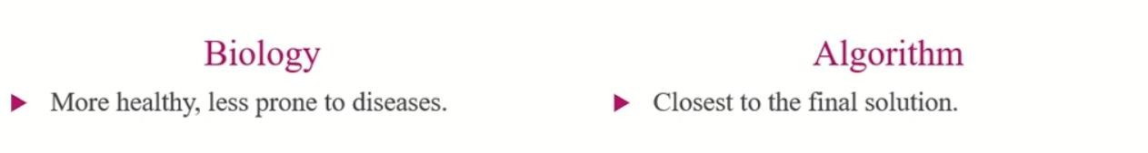

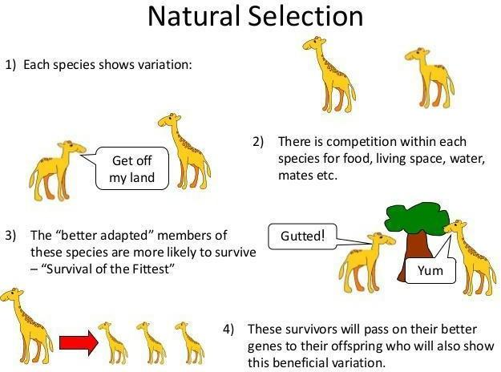
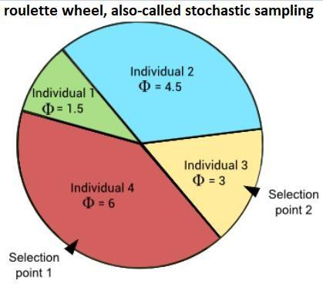

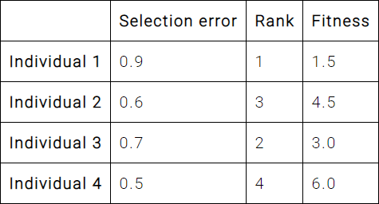

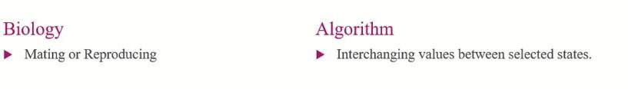
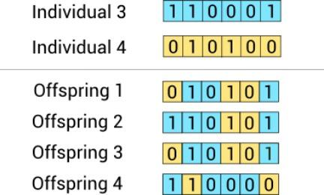
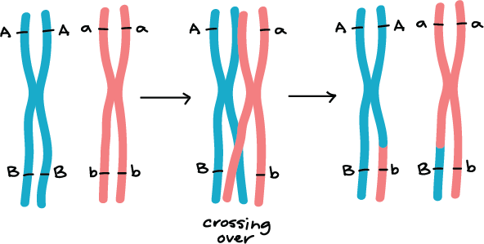
1.4 Mating / Crossover / Generating Generations

1.5 Mutation
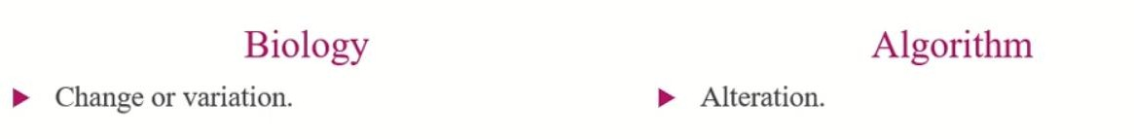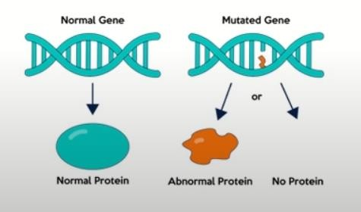

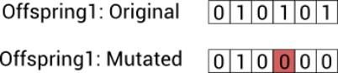

Problem Solving using Genetic Algorithm

Famous problems which use Genetic Algorithms:

KnapSack Problem
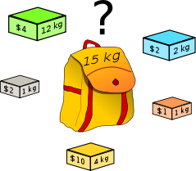

8 Queen Problem
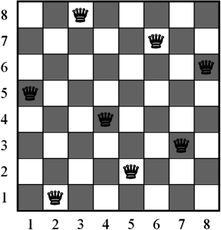

Optimization Problems/ Finding Global Maxima of a Function
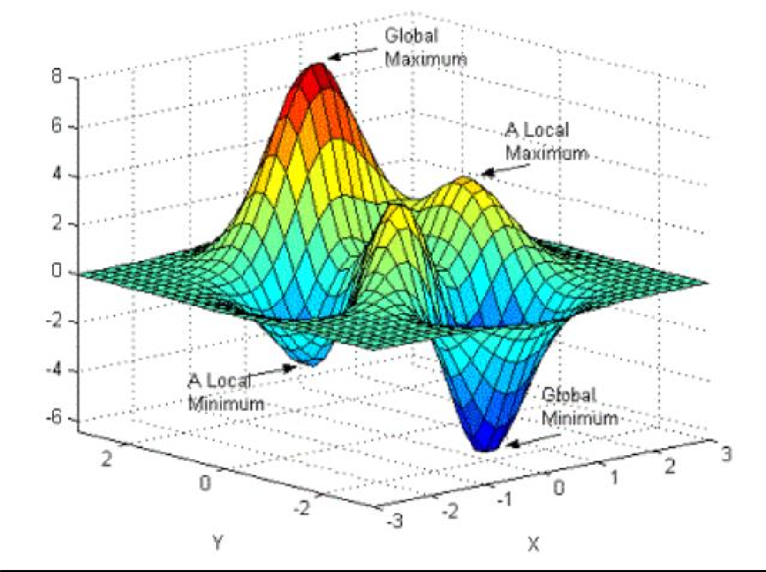

Let’s try to find optimized solution of a function:
Execute the attached notebook for this problem and follow the step by step details below for understanding.
Let’s have random expression which evaluates to 25:
6𝑥³ + 9𝑦² + 90𝑧¹ = 25

Problem: What could be the best possible values of x, y and z that could satisfy the above expression.
For this purpose, we make function in python such that:
def evaluateExpression(x, y, z):
return 6 * x ** 3 + 9 * y ** 2 + 90 * z - 25

This function that evaluates the expression to 0 if the answer of expression " 6 * x ** 3 + 9 * y
** 2 + 90 * z " is 25. So that means we need the most suitable values of x, y and z so that we could achieve our target value which is 25 in this case.

Now we need to apply Genetic Algorithm concepts to solve this problem.
Step1: Population of Solutions.
Population is generated entirely from random numbers let say up to 1000 individuals.

# generate solutions population import random
solutions = []
for counter in range(1000):
solutions.append((random.uniform(0, 1000), random.uniform(0, 1000), rand
om.uniform(0, 1000)))
Step2: Fitness function
So the fittest solution will be the one, which evaluates the expression to "0". Otherwise, the best solution will be closest to zero. Therefore, the fitness in this case is the highest if the solution is closest to zero. Hence, we can return the highest fitness value to those solutions, which are closest to 0.

def fitness(x, y, z):
ans = evaluateExpression(x, y, z)
if ans == 0: return 99999
else:
return abs(1 / ans)
Step3: Mating, Crossover or Generating the Generations
During each generations, further sub steps performed such as:
Step 3.1: Selection of top ranked solutions
Step 3.2: Mutation or slight changes or variation in values of solution.
P.S. Here for the sake of analogy if solution can be considered as chromosome then variable values can be considered as genes)

for generation_count in range(10000): rankedSolutions = []
# fitness step
for solution in solutions:
rankedSolutions.append((fitness(solution[0], solution[1], solution[2])
, solution)) rankedSolutions.sort() rankedSolutions.reverse()
print(f"=== Generation {generation_count} best solutions ====") print(rankedSolutions[0])
if rankedSolutions[0][0] > 999: break
bestSolution = rankedSolutions[:100] # print(bestSolution)
# selection step variables = []
for solution in bestSolution: variables.append(solution[1][0]) # variable x
variables.append(solution[1][1]) # variable y variables.append(solution[1][2]) # variable z
newGeneration = [] # mutation step
for counter in range(1000):
x = random.choice(variables) * random.uniform(0.99, 1.01)
y = random.choice(variables) * random.uniform(0.99, 1.01)
z = random.choice(variables) * random.uniform(0.99, 1.01) newGeneration.append((x, y, z))
solutions = newGeneration
Note: After running this code given in Jupyter Notebook, confirm the values from best optimized solution into given expression to verify.
Question 1
Topic: Population, Fitness and Selection
Use a Genetic Algorithm to maximize the function:
f(x)=x2f(x) = x^2f(x)=x2
Where x ranges from 0–15.
Given Initial Population
Chromosome | Decimal Value (x)
0011 | 3
0101 | 5
1001 | 9
1110 | 14

Tasks:
Tasks
- Calculate the fitness value f(x)=x2f(x) = x^2f(x)=x2 for each chromosome.
- Rank the chromosomes according to fitness value.
- Apply selection and choose the two best chromosomes as parents for the next generation.
----------------------
Question 2
Topic: Crossover / Generating Generations
A delivery company wants to find the shortest delivery route between four locations.
Locations
A, B, C, D
Distance Table
From | To | Distance
A | B | 10
A | C | 15
A | D | 20
B | C | 35
B | D | 25
C | D | 30

Given Initial Population (Routes)
- A → B → C → D
- A → C → B → D
- B → A → D → C
- C → B → A → D
Tasks
- Calculate the total distance (fitness) for each route.
- Select the two best routes as parents.
- Apply single-point crossover to generate two new offspring routes.
- Show the new generation of routes.

----------------------
Question 3
Topic: Mutation
An online warehouse wants to optimize product placement so that frequently purchased products are placed closer to the packing area.
Products and their demand levels are given as:
A (High), B (Medium), C (Low), D (High).
The given initial population (arrangements of products) is:
- A B C D
- B C A D
- D A B C
- C B D A
Tasks
- Represent each product arrangement as a chromosome.
- Apply mutation by randomly swapping two product positions in each chromosome.
- Write the new mutated population.
- Briefly explain how mutation helps in finding better product placement.
----------------------
Question 4
Topic: Problem Solving using Genetic Algorithm
A factory wants to determine the best values of x, y, and z that satisfy the equation:
6x3+9y2+90z=256x^3 + 9y^2 + 90z = 256x3+9y2+90z=25
The initial population of possible solutions is given as:
- (1, 1, 0)
- (2, 1, 0)
- (1, 2, 0)
- (2, 2, 0)
The fitness function is:
fitness=1∣6x3+9y2+90z−25∣fitness = \frac{1}{|6x^3 + 9y^2 + 90z - 25|}fitness=∣6x3+9y2+90z−25∣1​
Tasks
- Evaluate the expression 6x³ + 9y² + 90z for each solution.
- Calculate the fitness value for each solution.
- Select the two best solutions based on highest fitness.
- Apply mutation by slightly changing the values of x, y, or z (±0.1) to generate a new population.
- Repeat the process for several generations to approach the target value 25.

